**PES UNIVERSITY**

**DBMS: VIRTUAL MONEY TRANSFER**



**Submitted By:**

**Name: ANSHIKA PAL**

**SRN: PES1UG20CS062**

**V Semester Section B**

**DESCRIPTION:**

Virtual Money Transfer(E- Wallet) online payment portal, created using mysql and streamlit(python) with a MySQL database, where users can transfer money through virtual wallets. Transactions involving virtual currencies occur through secure, dedicated networks or over the Internet.

It allows to send money from one person to another and also keeps the history about all the previous transactions. You are also given Promo Offers which one can use and get rewards. This also allows people to give referral to other people and can claim offers. It will also show the loan on a person.

**SCOPE:**

1. Customers can perform financial transactions like transfer funds online, pay bills, apply for loans and open a savings account among various other debit card transactions.
2. You can transfer the funds 24/7 without going to the physical bank.
3. Check account Balance and statements.
4. One can apply for loans.
5. Make investments.
6. Bill payments and recharge.
7. Depositing and withdrawing money.

**ER Diagram:**

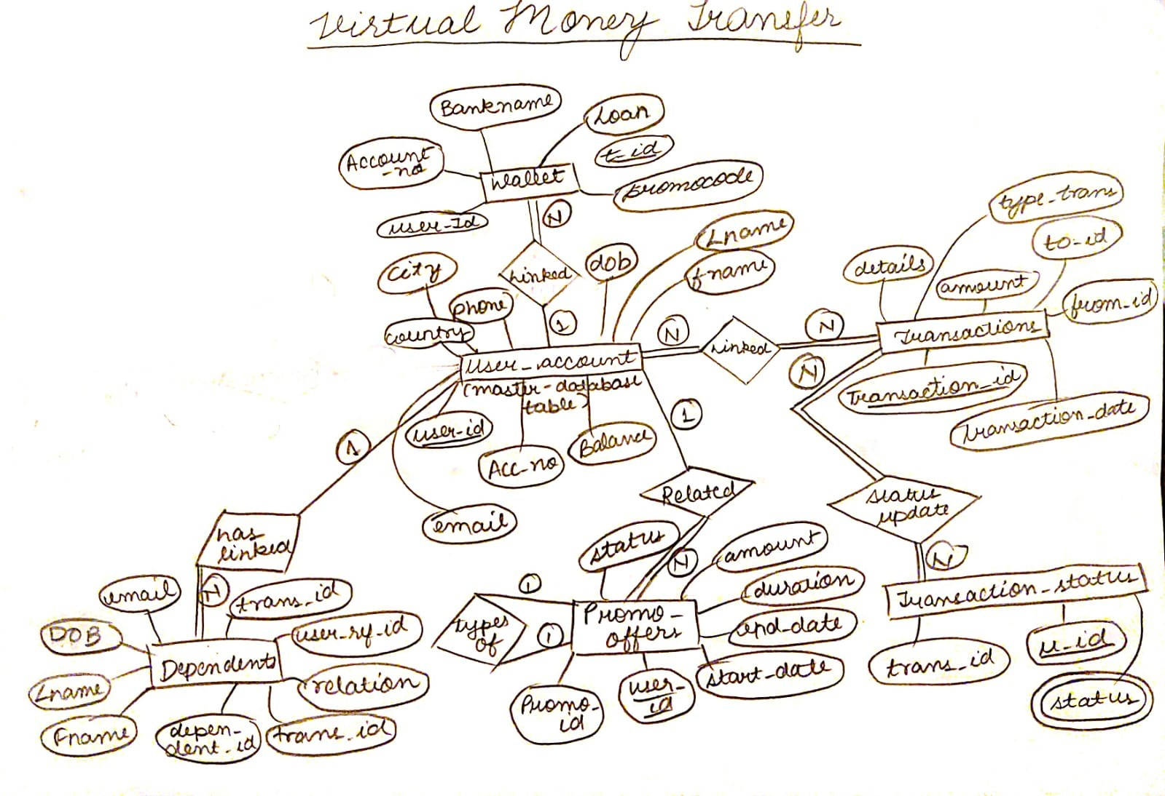

**Relational Schema:**

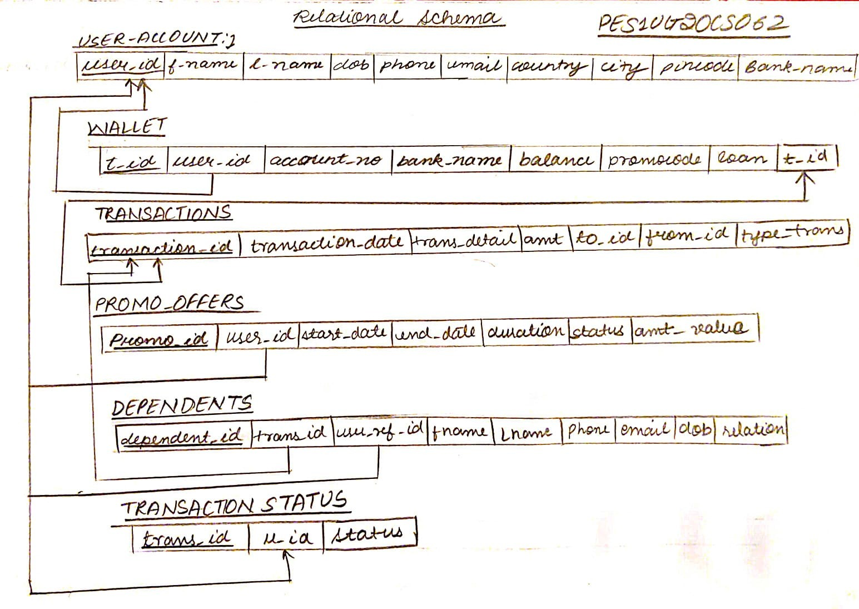

**DDL statements - Building the database:**

**create_databse.sql**

create table user_account(user_id varchar(10),

fname varchar(15) NOT NULL,

lname varchar(15) NOT NULL,

dob varchar(30) NOT NULL,

phone varchar(10) NOT NULL ,

email varchar(40) NOT NULL,

country varchar(20) NOT NULL,

city varchar(30),

pincode int(6),

bank_name varchar(20) NOT NULL,

primary key(user_id));

create table wallet(t_id varchar(20) NOT NULL,

user_id varchar(20) NOT NULL,

account_no varchar(20) NOT NULL,

bank_name varchar(30) NOT NULL,

balance int check(balance > 0),

promocode varchar(20) default NULL,

loan varchar(10) default NULL,

primary key(t_id,user_id,promocode));

create table transactions(transaction_id varchar(10),

transaction_date varchar(20),

transaction_detail varchar(30),

amount int check (amount>100),

to_id varchar(20),

from_id varchar(20),

type_trans varchar(20),

primary key(transaction_id,to_id,from_id));

create table promo_offers(promo_id varchar(10),

user_id varchar(10),

start_date varchar(20) NOT NULL,

end_date varchar(20) NOT NULL,

duration varchar(20) NOT NULL,

status varchar(20) NOT NULL,

amount_value varchar(50) NOT NULL,

primary key(promo_id,user_id),

FOREIGN KEY (user_id) REFERENCES user_account(user_id) ON DELETE CASCADE);

create table dependents(dependent_id varchar(10) NOT NULL,

trans_id varchar(10) UNIQUE,

user_ref_id varchar(20),

fname varchar(20) NOT NULL,

lname varchar(20) NOT NULL,

phone varchar(10) NOT NULL,

email varchar(50) NOT NULL,

dob varchar(30) NOT NULL,

relation varchar(20) NOT NULL UNIQUE,

primary key(dependent_id,trans_id,user_ref_id));

create table transaction_status(trans_id varchar(10),

u_id varchar(10),

primary key (trans_id,u_id));

ALTER TABLE wallet ADD CONSTRAINT FK_t_id FOREIGN KEY (t_id) REFERENCES transactions(transaction_id) ON DELETE CASCADE;

ALTER TABLE transaction_status

ADD CONSTRAINT FK_u_id

FOREIGN KEY (u_id) REFERENCES user_account(user_id)

ON DELETE CASCADE;

ALTER TABLE transaction_status

ADD status varchar(15);

**Populating the Database:**

**insert_data.sql**

insert into user_account values ('VB201701','Vishal','Khanna','15-03-1979','9912121212','vishalkhanna@yahoo.com','India','Chandigarh','123456','State Bank Of India');

insert into user_account values ('VB201702','Anuj','Bhushan','05-06-1996','8197765465','anujbhushan5@gmail.com','India','Bangalore','123890','State Bank Of India');

insert into user_account values ('VB201703','Aniket','Bharati','11-01-1997','8147364941','bharatianiket@gmail.com','India','Bangalore','123890','Union Bank Of India');

insert into user_account values ('VB201704','Ankit','Reddy','11-02-1997','8179949418','hdreddy97@gmail.com','India','Bangalore','123890','ICICI Bank');

insert into user_account values ('VB201705','Shreya','Narayan','11-09-1996','9913131313','narayanshreya@yahoo.com','India','Mangalore','123476','Axis Bank');

insert into user_account values ('VB201706','Dilip','Joshi','01-01-1980','9914141414','dilipjoshi@yahoo.com','India','Delhi','123019','Axis Bank');

/*insert into wallet values('T-220001','VB201701','SBIN201701','State Bank Of India',7500,'','');*/

insert into wallet values('T-220002','VB201702','SBIN201702','State Bank Of India',45000,'VB_MAR','');

insert into wallet values('T-220003','VB201703','UBIN201703','State Bank Of India',6000,'VB_MAR','1200');

insert into wallet values('T-220004','VB201704','ICIN201704','State Bank Of India',50000,'VB_MAR','');

insert into wallet values('T-220005','VB201705','AXIN201705','State Bank Of India',9500,'','5000');

insert into wallet values('T-220006','VB201706','AXIN201706','State Bank Of India',1000,'','2000');

insert into transactions values('T-220002','22-03-2017','Transfer to Wife','50000','VB201705','VB201702','Wallet Transfer');

insert into transactions values('T-220003','22-03-2017','Transfer to Friend','20000','VB201704','VB201703','NEFT Transfer');

insert into transaction_status values('T-220002','VB201702',’Completed’);

insert into transaction_status values('T-220003','VB201703',’Failed’);

insert into promo_offers values('VB_MAR','VB201702','01-03-2017','31-03-2017','30 days','Active','Rs. 1000 V_Credit');

insert into promo_offers values('VB_MAR','VB201703','01-03-2017','31-03-2017','30 days','Active','Rs. 1000 V_Credit');

insert into promo_offers values('VB_MAR','VB201704','01-03-2017','31-03-2017','30 days','Active','Rs. 1000 V_Credit');

insert into dependents values('VBDP001','T-210002','T-220002','Virat','Kohli','8812121212','vkohli87@gmail.com','20-01-1987','Brother');

insert into dependents values('VBDP002','T-210004','T-220004','Neha','Krishna','8814141414','krihna_neha97@rediffmail.com','20-02-1987','Wife');

insert into dependents values('VBDP003','T-210005','T-220005','Vaibhav','Bhushan','8815151515','vaibhav_born99@gmail.com','20-03-1980','Brother In Law');

**Join Queries:**

1. **Displaying user_id, account_no, bank_name and transaction details of a person sending money to relative.**

**QUERY:**



**RESULT:**

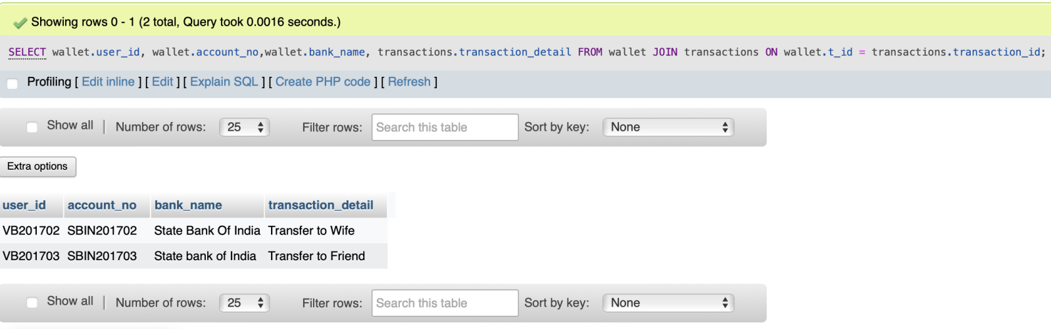

1. **SELECT transaction_id,u_id,to_id,from_id, status from joining tables transactions and transaction_status on transaction id. (Showing if the transaction is completed or not).**

**QUERY:**



**RESULT:**

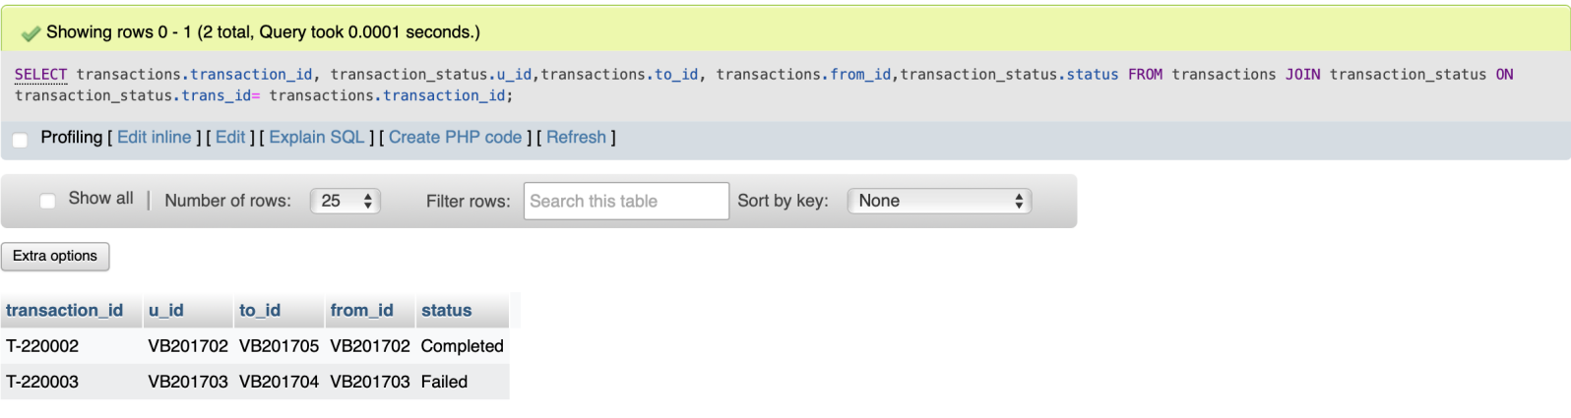

1. **Selecting transaction_id, dependent_id, relation, transaction_typ and relation by joining tables transactions and dependents.**

**QUERY:**



**RESULT:**

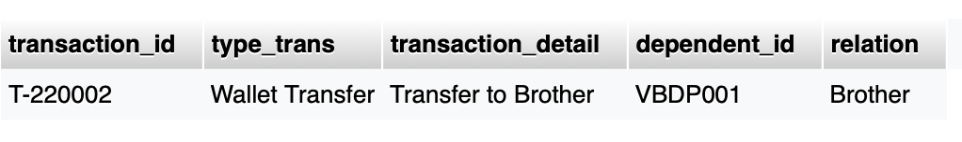

1. **Show the user_id with it’s name and bank number and how much balance and loan is there on a person.**

**QUERY:**



**RESULT:**

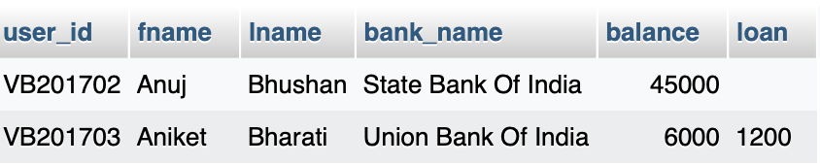

**AGGREGATE FUNCTIONS:**

1. **Counting the number of banks that user is associated with.**

**QUERY:**

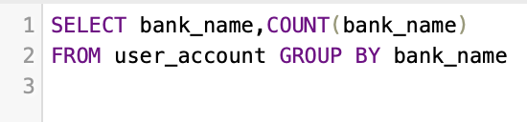

**RESULT:**

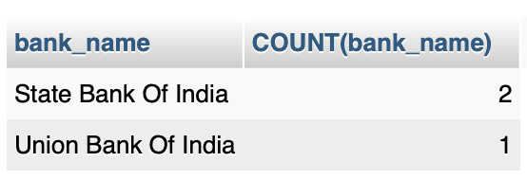

1. **Show total sum sent to a person.**

**QUERY:**

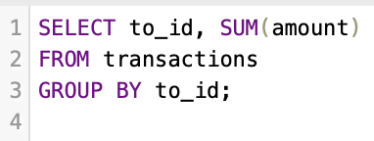

**RESULT:**

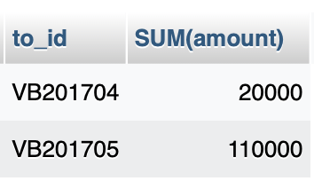

1. **Give average values of balance on which the transactions takes place of all the banks.**

**QUERY:**

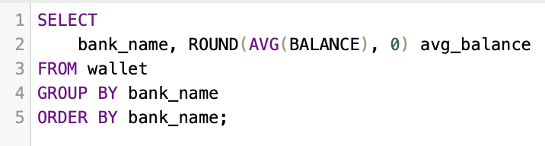

**RESULT:**

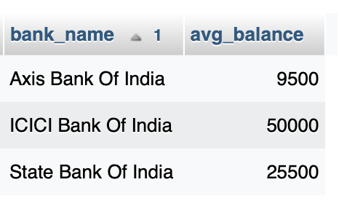

1. **Highest balance of all the users in the wallet.**

**QUERY:**

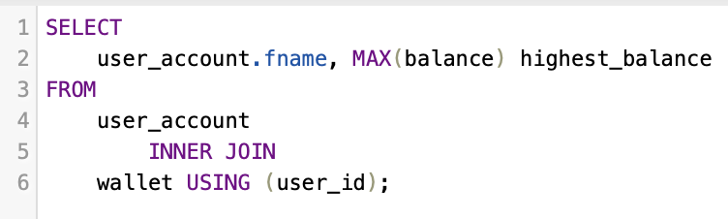

**RESULT:**

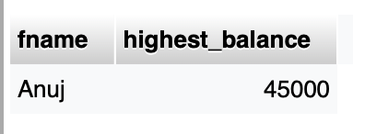

**#ANUJ HAS HIGHEST BALANCE**

**Set Operations:**

1. **Perform union function on user_id and bank_name on user_account and wallet columns.**

**QUERY:**

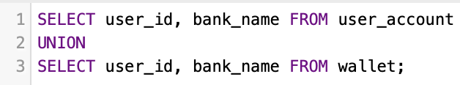

**RESULT:**

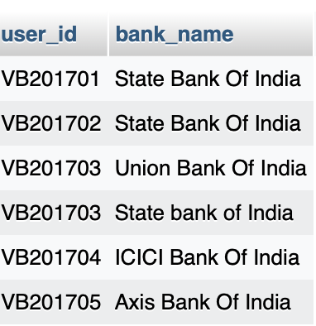

1. **UNION ALL on transaction id of wallet and transactions.**

**QUERY:**

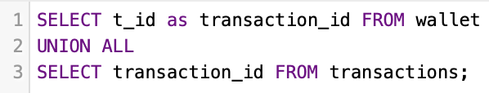

**RESULT:**

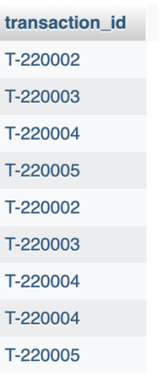

1. **Bank name tp which a person registered while living in different countries (i.e. India and America).**

**QUERY:**

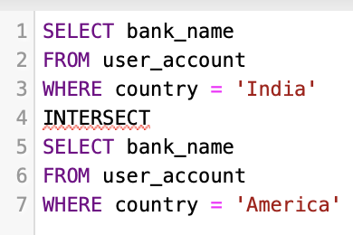

**RESULT:**

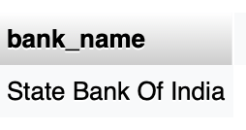

1. **Users which didnot give refferal to any person (or have any dependents).**

**QUERY:**

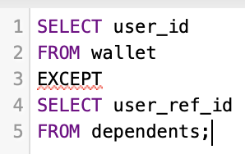

**RESULT:**

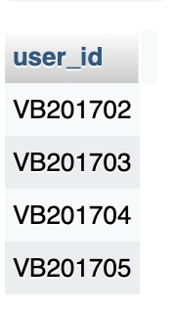

**Functions and Procedures:**

**PROCEDURE:**

**QUERY:**

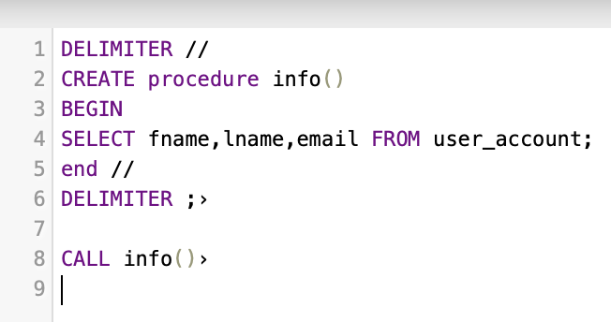

**RESULTS:**

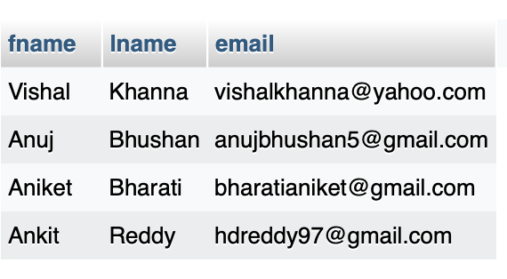

**FUNCTION:**

**QUERY:**

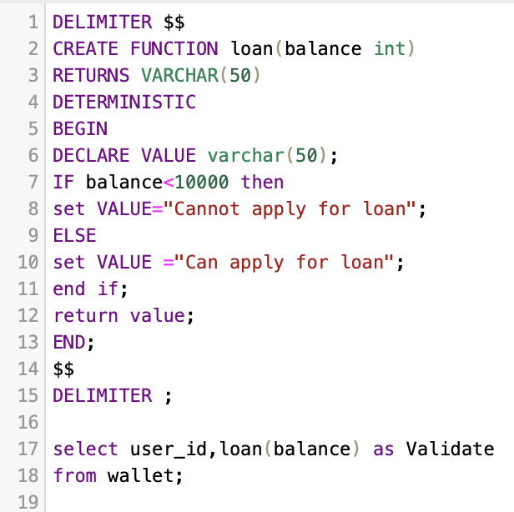

**RESULTS:**

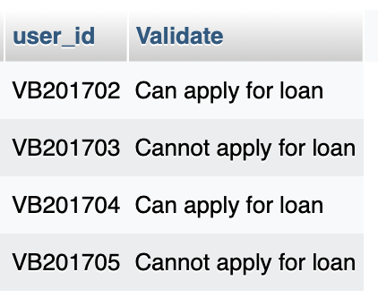

**TRIGGERS AND CURSORS:**

**TRIGGERS:**

**QUERY:**

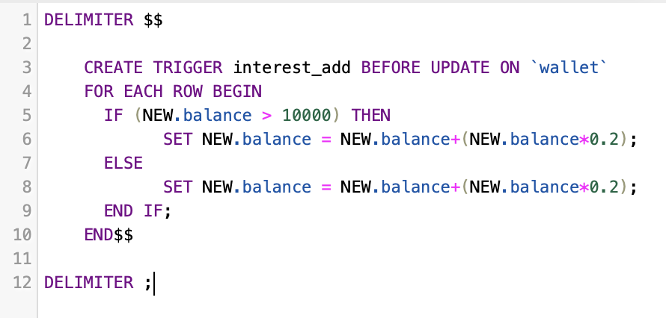

**RESULT:**

**UPDATED THE BALANCE TO 20000 WHICH IS > 10000:**

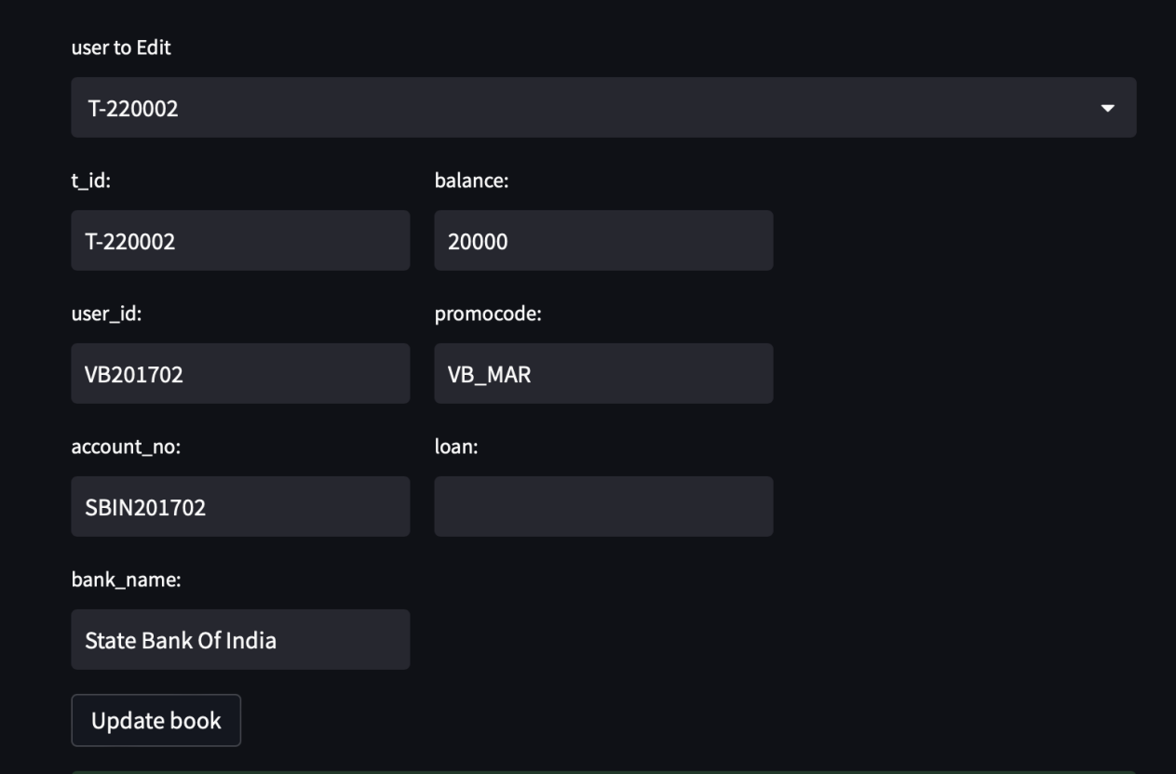

**AFTER UPDATION INTEREST OF 0.2 GOT ADDED ACC. TO CONDITION**

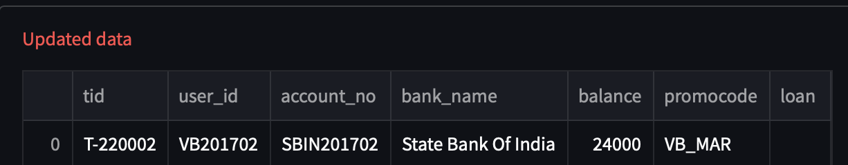

**CURSORS:**

**QUERY:**

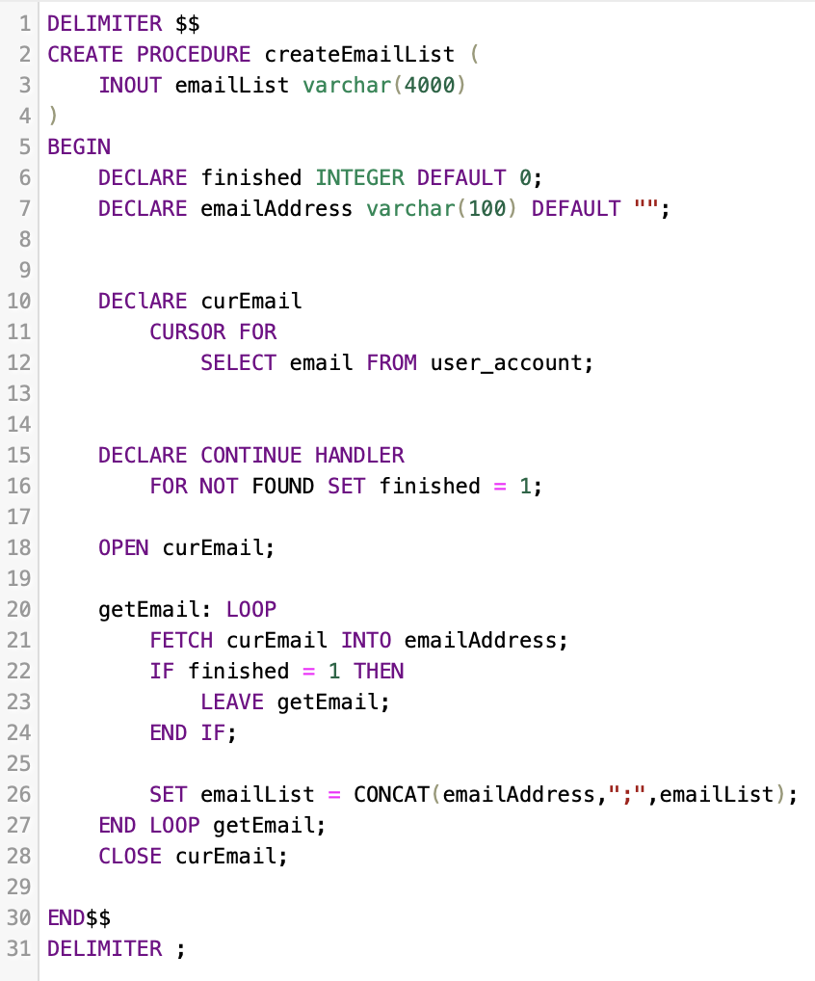

**RESULT:**

**LIST OF ALL EMAILS:**

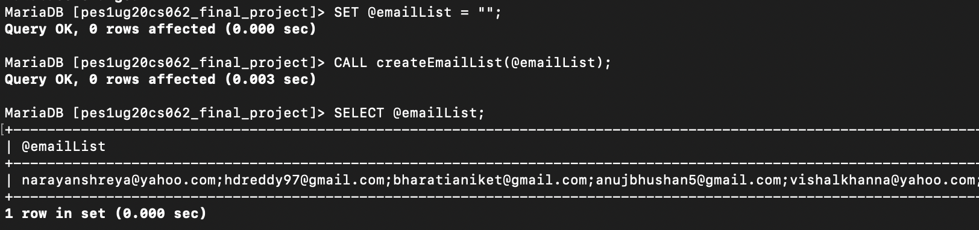

**Developing a Frontend:**

**MAIN PAGE:**

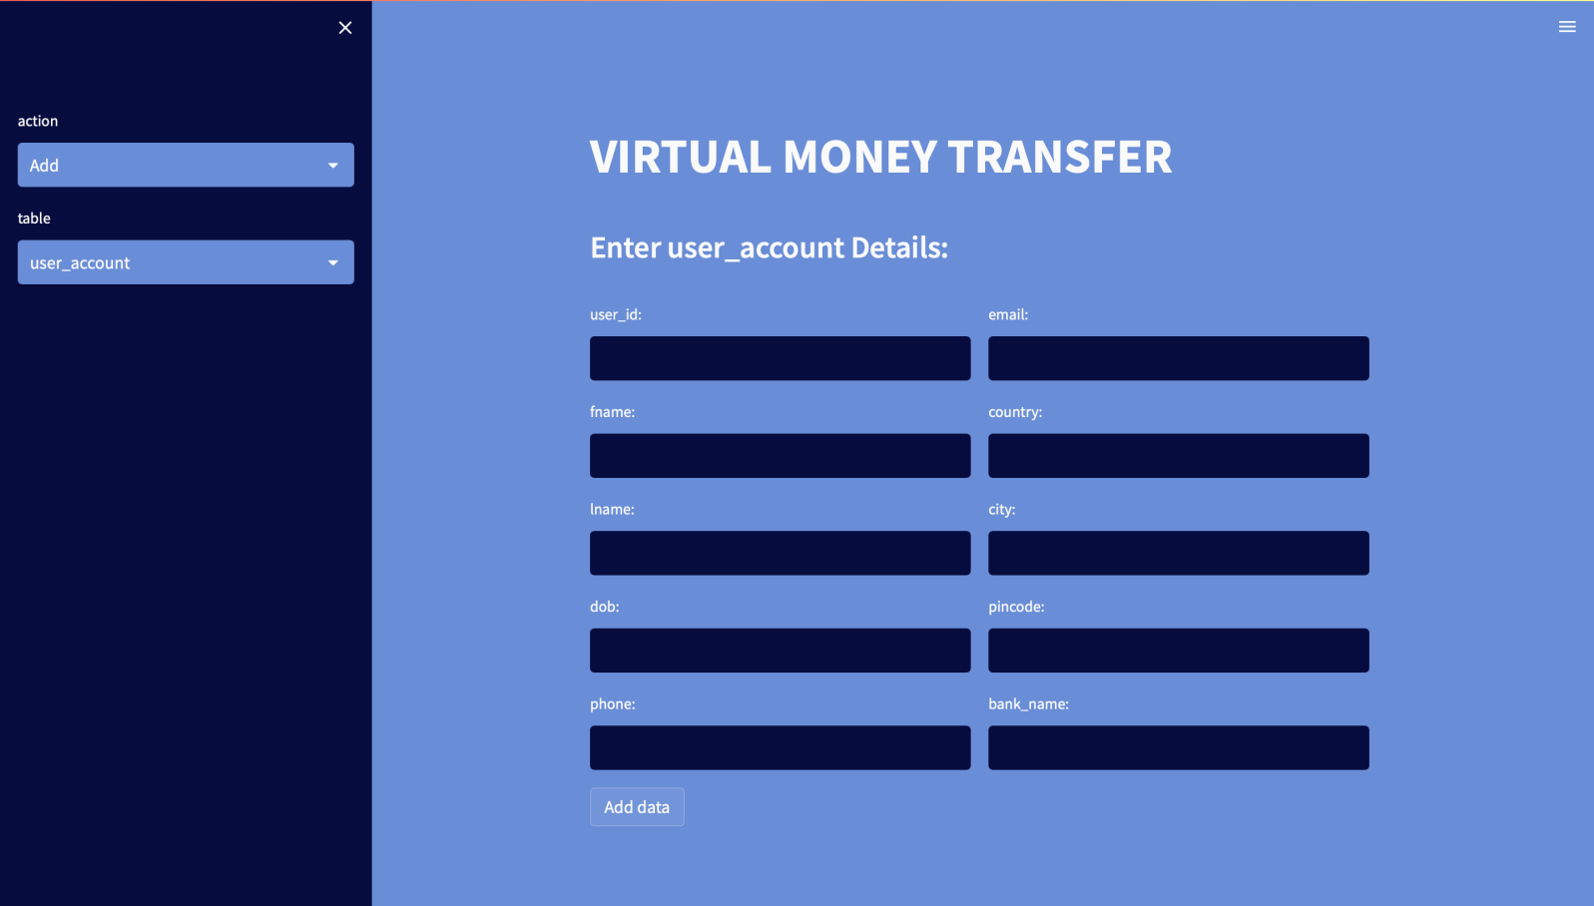

**NAVIGATE THROUGH TABLES:**

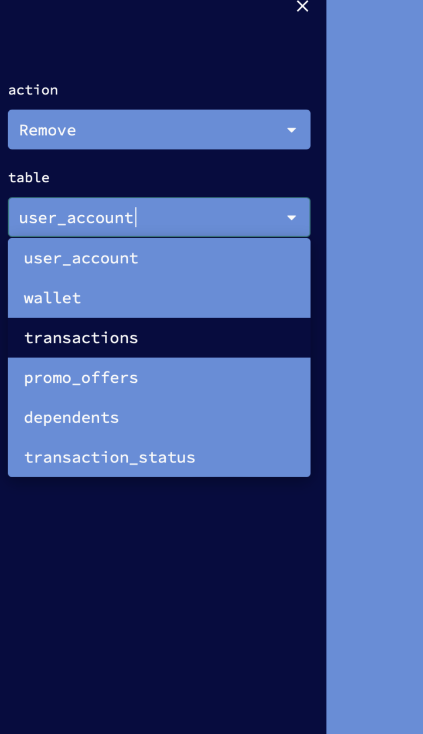

**ADDING VALUES:**

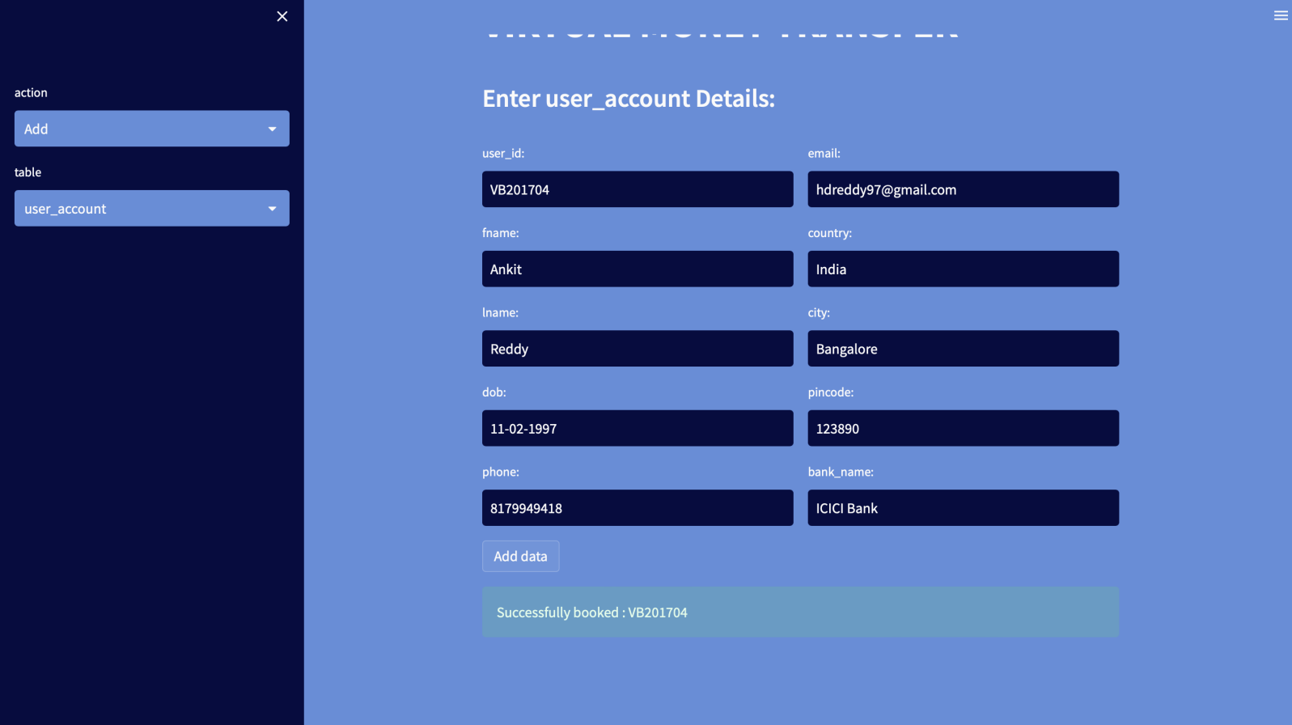

**VIEWING VALUES:**

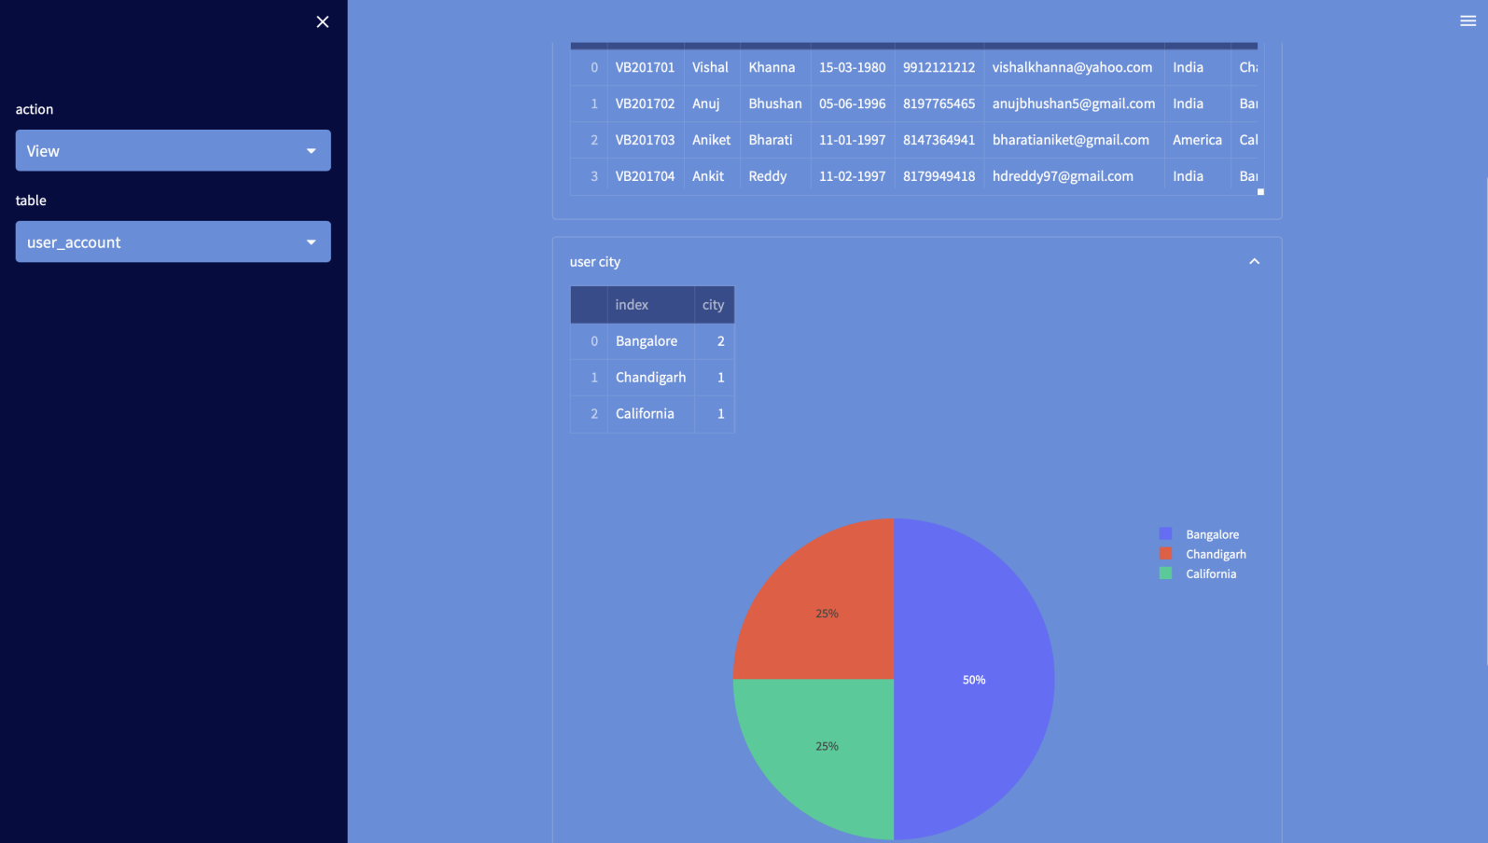

**DROP DOWN MENU TO CHOOSE ON WHICH VALUE TO EDIT:**

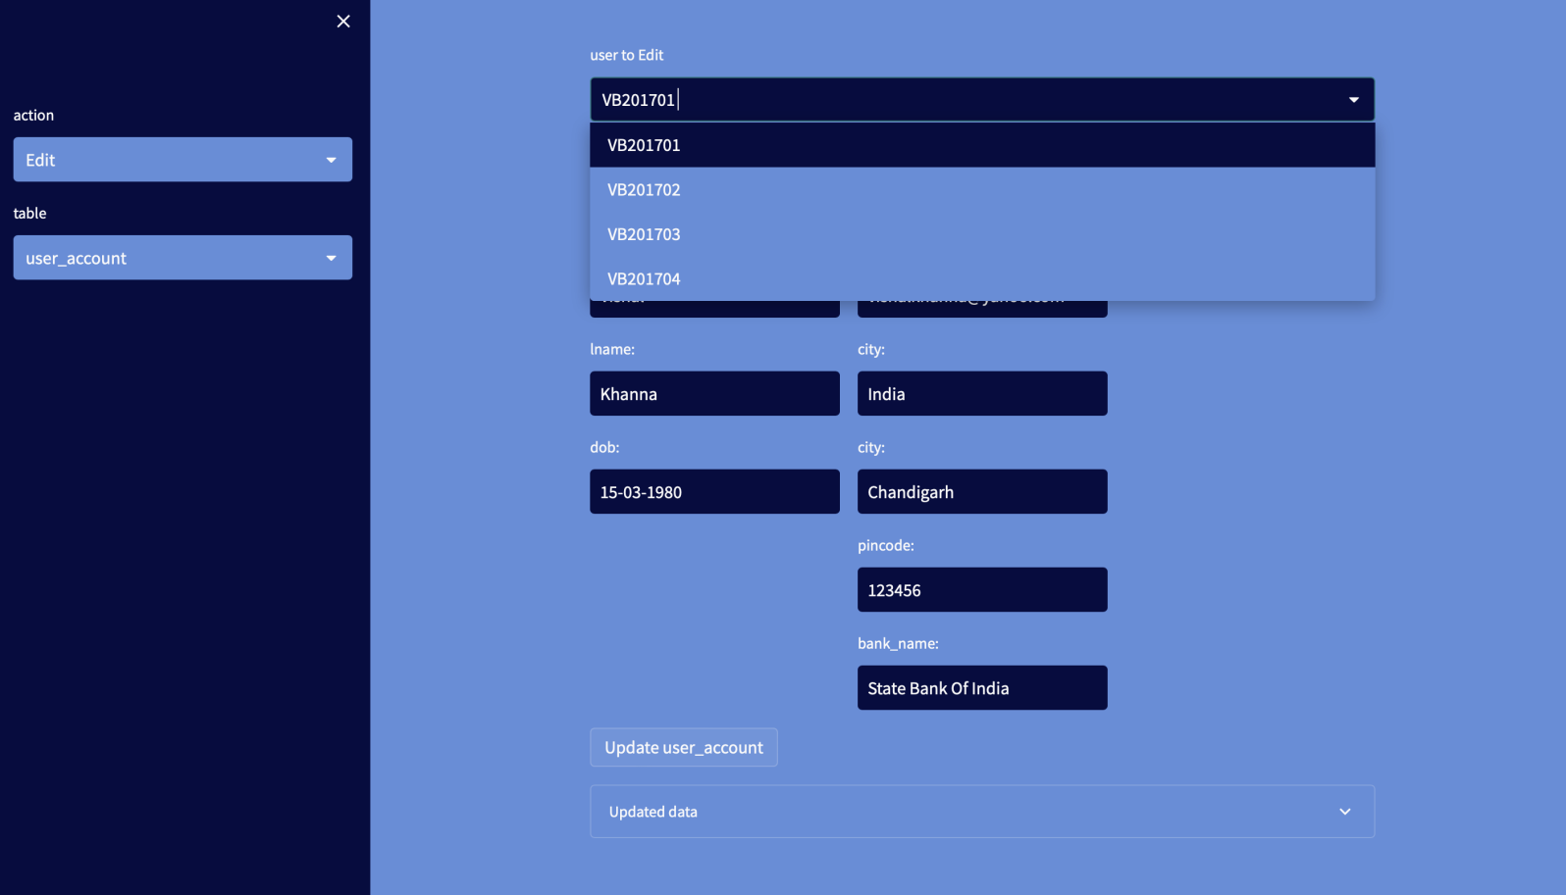

**UPDATING THE VALUES:**

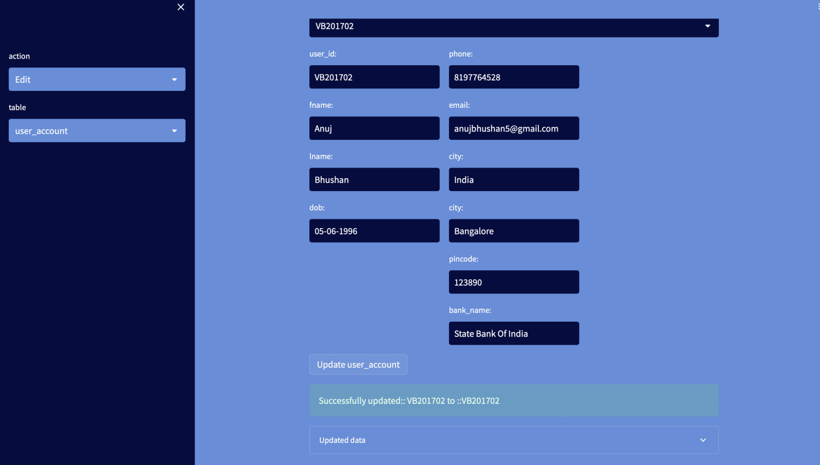

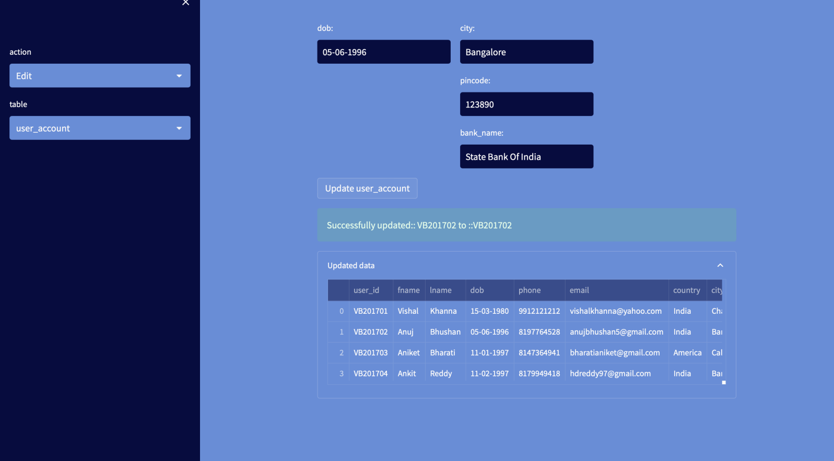

**DELETING THE VALUES:**

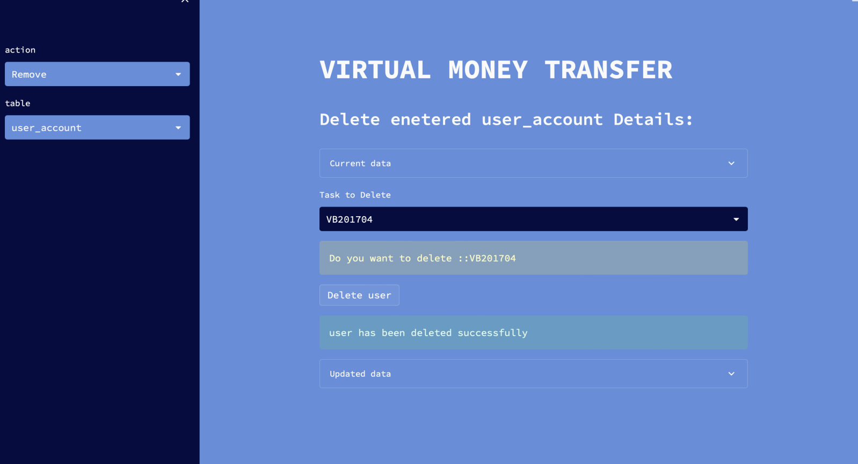

**CODE:**

**app.py**

# Importing pakages

import streamlit as st

import mysql.connector

from create import create

from database import create_table

from delete import delete

from read import read

from update import update

mydb = mysql.connector.connect(

host="localhost",

user="root"

)

c = mydb.cursor()

# c.execute("CREATE DATABASE pes1ug20cs062_final_project")

c.execute("use pes1ug20cs062_final_project")

def main():

st.title("VIRTUAL MONEY TRANSFER")

menu = ["Add", "View", "Edit", "Remove"]

table_names=["user_account","wallet","transactions","promo_offers","dependents","transaction_status"]

choice = st.sidebar.selectbox("action", menu)

table=st.sidebar.selectbox("table", table_names)

create_table(table)

if choice == "Add":

if table=='user_account':

st.subheader("Enter user_account Details:")

create(table)

elif table=='wallet':

st.subheader("Enter wallet Details:")

create(table)

elif table=='transactions':

st.subheader("Enter transactions Details:")

create(table)

elif table=='promo_offers':

st.subheader("Enter promo_offers Details:")

create(table)

elif table=='dependents':

st.subheader("Enter dependents Details:")

create(table)

elif table=='transaction_status':

st.subheader("Enter transaction_status Details:")

create(table)

if choice == "View":

if table=='user_account':

st.subheader("View entered user_account Details:")

read(table)

elif table=='wallet':

st.subheader("View entered wallet Details:")

read(table)

elif table=='transactions':

st.subheader("View entered transactions Details:")

read(table)

elif table=='promo_offers':

st.subheader("View entered promo_offers Details:")

read(table)

elif table=='dependents':

st.subheader("View entered dependents Details:")

read(table)

elif table=='transaction_status':

st.subheader("View entered transaction_status Details:")

read(table)

if choice == "Remove":

if table=='user_account':

st.subheader("Delete enetered user_account Details:")

delete(table)

elif table=='wallet':

st.subheader("Delete entered wallet Details:")

delete(table)

elif table=='transactions':

st.subheader("Delete entered transactions Details:")

delete(table)

elif table=='promo_offers':

st.subheader("Delete entered promo_offers Details:")

delete(table)

elif table=='dependents':

st.subheader("Delete entered dependents Details:")

delete(table)

elif table=='transaction_status':

st.subheader("Delete entered transaction_status Details:")

delete(table)

if choice == "Edit":

if table=='user_account':

st.subheader("Update entered user_account Details:")

update(table)

elif table=='wallet':

st.subheader("Update entered wallet Details:")

update(table)

elif table=='transactions':

st.subheader("Update entered transactions Details:")

update(table)

elif table=='promo_offers':

st.subheader("Update entered promo_offers Details:")

update(table)

elif table=='dependents':

st.subheader("Update entered dependents Details:")

update(table)

elif table=='transaction_status':

st.subheader("Update entered transaction_status Details:")

update(table)

if __name__ == '__main__':

main()

**create.py:**

import streamlit as st

from database import add_data_user_account

from database import add_data_wallet

from database import add_data_transactions

from database import add_data_promo_offers

from database import add_data_dependents

from database import add_data_transaction_status

def create(table):

if table=='user_account':

col1, col2 = st.columns(2)

with col1:

user_id = st.text_input("user_id:")

fname = st.text_input("fname:")

lname = st.text_input("lname:")

dob = st.text_input("dob:")

phone = st.text_input("phone:")

with col2:

email = st.text_input("email:")

country = st.text_input("country:")

city = st.text_input("city:")

pincode= st.text_input("pincode:")

bank_name = st.text_input("bank_name:")

if st.button("Add data"):

add_data_user_account(user_id,fname,lname ,dob ,phone ,email ,country ,city ,pincode,bank_name)

st.success("Successfully booked : {}".format(user_id))

elif table=='wallet':

col1, col2 = st.columns(2)

with col1:

t_id = st.text_input("t_id:")

user_id = st.text_input("user_id:")

account_no = st.text_input("account_no:")

bank_name = st.text_input("bank_name:")

with col2:

balance = st.text_input("balance:")

promocode = st.text_input("promocode:")

loan = st.text_input("loan:")

if st.button("Add data"):

add_data_wallet(t_id,user_id,account_no, bank_name,balance,promocode,loan)

st.success("Successfully added : {}".format(t_id))

elif table == 'transactions':

col1, col2 = st.columns(2)

with col1:

transaction_id = st.text_input("transaction_id:")

transaction_date = st.text_input("transaction_date:")

transaction_detail = st.text_input("transaction_detail:")

amount = st.text_input("amount:")

with col2:

to_id = st.text_input("to_id:")

from_id = st.text_input("from_id:")

type_trans = st.text_input("type_trans:")

if st.button("Add data"):

add_data_transactions(transaction_id, transaction_date,transaction_detail, amount,to_id,from_id,type_trans)

st.success("Successfully added : {}".format(transaction_id))

elif table == 'promo_offers':

col1, col2 = st.columns(2)

with col1:

promo_id = st.text_input("promo_id:")

user_id = st.text_input("user_id:")

start_date = st.text_input("start_date:")

end_date = st.text_input("end_date:")

with col2:

duration = st.text_input("duration:")

status = st.text_input("status:")

amount_value = st.text_input("amount_value:")

if st.button("Add data"):

add_data_promo_offers(promo_id,user_id,start_date,end_date,duration,status, amount_value)

st.success("Successfully added : {}".format(promo_id))

elif table == 'dependents':

col1, col2 = st.columns(2)

with col1:

dependent_id = st.text_input("dependent_id:")

trans_id = st.text_input("trans_id:")

user_ref_id = st.text_input("user_ref_id:")

fname = st.text_input("fname:")

lname = st.text_input("lname:")

with col2:

phone = st.text_input("phone:")

email = st.text_input("email:")

dob = st.text_input("dob:")

relation = st.text_input("relation:")

if st.button("Add data"):

add_data_dependents(dependent_id,trans_id,user_ref_id,fname,lname,phone,email,dob,relation)

st.success("Successfully added : {}".format(dependent_id))

elif table == 'transaction_status':

col1, col2 = st.columns(2)

with col1:

trans_id = st.text_input("trans_id:")

u_id = st.text_input("uid:")

status = st.text_input("status:")

if st.button("Add data"):

add_data_transaction_status(trans_id,u_id,status)

st.success("Successfully added : {}".format(trans_id))

**database.py**

# pip install mysql-connector-python

import mysql.connector

mydb = mysql.connector.connect(

host="localhost",

user="root",

database="pes1ug20cs062_final_project"

)

c = mydb.cursor()

def create_table(table):

if table=='uder_account':

c.execute('CREATE TABLE IF NOT EXISTS user_account(user_id TEXT,fname TEXT,lname TEXT,dob TEXT,phone TEXT,email TEXT,country TEXT,city TEXT,pincode TEXT,bank_name TEXT)')

elif table=='wallet':

c.execute('CREATE TABLE IF NOT EXISTS wallet(t_id TEXT ,user_id TEXT,account_no TEXT, bank_name TEXT,balance TEXT,promocode TEXT,loan TEXT)')

elif table=='transactions':

c.execute('CREATE TABLE IF NOT EXISTS transactions(transaction_id TEXT, transaction_date TEXT,transaction_detail TEXT, amount TEXT,to_id TEXT,from_id TEXT,type_trans TEXT)')

elif table=='promo_offers':

c.execute('CREATE TABLE IF NOT EXISTS promo_offers(promo_id TEXT,user_id TEXT,start_date TEXT,end_date TEXT,duration TEXT,status TEXT, amount_value TEXT)')

elif table=='dependents':

c.execute('CREATE TABLE IF NOT EXISTS dependents(dependent_id TEXT,trans_id TEXT,user_ref_id TEXT,fname TEXT,lname TEXT,phone TEXT,email TEXT,dob TEXT,relation TEXT)')

elif table=='transaction_status':

c.execute('CREATE TABLE IF NOT EXISTS transaction_status(trans_id TEXT,u_id TEXT,status TEXT)')

def add_data_user_account(user_id,fname,lname ,dob ,phone ,email ,country ,city ,pincode,bank_name):

c.execute('INSERT INTO user_account(user_id,fname,lname ,dob ,phone ,email ,country ,city ,pincode,bank_name) VALUES (%s,%s,%s,%s,%s,%s,%s,%s,%s,%s)',

(user_id,fname,lname ,dob ,phone ,email ,country ,city ,pincode,bank_name))

mydb.commit()

def add_data_wallet(t_id,user_id,account_no, bank_name,balance,promocode,loan):

c.execute('INSERT INTO wallet(t_id,user_id,account_no, bank_name,balance,promocode,loan) VALUES (%s,%s,%s,%s,%s,%s,%s)',

(t_id,user_id,account_no, bank_name,balance,promocode,loan))

mydb.commit()

def add_data_transactions(transaction_id, transaction_date,transaction_detail, amount,to_id,from_id,type_trans):

c.execute('INSERT INTO transactions(transaction_id, transaction_date,transaction_detail, amount,to_id,from_id,type_trans) VALUES (%s,%s,%s,%s,%s,%s,%s)',

(transaction_id, transaction_date,transaction_detail, amount,to_id,from_id,type_trans))

mydb.commit()

def add_data_promo_offers(promo_id,user_id,start_date,end_date,duration,status, amount_value):

c.execute('INSERT INTO promo_offers(promo_id,user_id,start_date,end_date,duration,status, amount_value) VALUES (%s,%s,%s,%s,%s,%s,%s)',

(promo_id,user_id,start_date,end_date,duration,status, amount_value))

mydb.commit()

def add_data_dependents(dependent_id,trans_id,user_ref_id,fname,lname,phone ,email ,dob,relation):

c.execute('INSERT INTO dependents(dependent_id,trans_id,user_ref_id,fname,lname,phone ,email ,dob,relation) VALUES (%s,%s,%s,%s,%s,%s,%s,%s,%s)',

(dependent_id,trans_id,user_ref_id,fname,lname,phone ,email ,dob,relation))

mydb.commit()

def add_data_transaction_status(trans_id,u_id,status):

c.execute('INSERT INTO transaction_status(trans_id,u_id,status) VALUES (%s,%s,%s)',

(trans_id,u_id,status))

mydb.commit()

#view tables

def view_all_user_account():

c.execute('SELECT * FROM user_account')

data = c.fetchall()

return data

def view_all_wallet():

c.execute('SELECT * FROM wallet')

data = c.fetchall()

return data

def view_all_data_transactions():

c.execute('SELECT * FROM transactions')

data = c.fetchall()

return data

def view_all_data_promo_offers():

c.execute('SELECT * FROM promo_offers')

data = c.fetchall()

return data

def view_all_data_dependents():

c.execute('SELECT * FROM dependents')

data = c.fetchall()

return data

def view_all_data_transaction_status():

c.execute('SELECT * FROM transaction_status')

data = c.fetchall()

return data

#viewonly tables

def view_only_user_account():

c.execute('SELECT user_id FROM user_account')

data = c.fetchall()

return data

def view_only_wallet():

c.execute('SELECT t_id FROM wallet')

data = c.fetchall()

return data

def view_only_data_transactions():

c.execute('SELECT transaction_id FROM transactions')

data = c.fetchall()

return data

def view_only_data_promo_offers():

c.execute('SELECT promo_id FROM promo_offers')

data = c.fetchall()

return data

def view_only_data_dependents():

c.execute('SELECT dependent_id FROM dependents')

data = c.fetchall()

return data

def view_only_data_transaction_status():

c.execute('SELECT trans_id FROM transaction_status')

data = c.fetchall()

return data

#getting

def get_user_id(user_id):

c.execute('SELECT * FROM user_account WHERE user_id="{}"'.format(user_id))

data = c.fetchall()

return data

def get_tid(t_id):

c.execute('SELECT * FROM wallet WHERE t_id="{}"'.format(t_id))

data = c.fetchall()

return data

def get_transaction_id(transaction_id):

c.execute('SELECT * FROM transactions WHERE transaction_id="{}"'.format(transaction_id))

data = c.fetchall()

return data

def get_promo_id(promo_id):

c.execute('SELECT * FROM promo_offers WHERE promo_id="{}"'.format(promo_id))

data = c.fetchall()

return data

def get_dependent_id(dependent_id):

c.execute('SELECT * FROM dependents WHERE dependent_id="{}"'.format(dependent_id))

data = c.fetchall()

return data

def get_trans_id(trans_id):

c.execute('SELECT * FROM transaction_status WHERE trans_id="{}"'.format(trans_id))

data = c.fetchall()

return data

#editig

def edit_user_account_data(new_user_id,new_fname,new_lname ,new_dob ,new_phone ,new_email ,new_country ,new_city ,new_pincode,new_bank_name,user_id,fname,lname ,dob ,phone ,email ,country ,city ,pincode,bank_name):

c.execute("UPDATE user_account SET user_id=%s,fname=%s, lname=%s, dob=%s, phone=%s,email=%s,country=%s,city=%s,pincode=%s,bank_name=%s WHERE "

"user_id=%s and fname=%s and lname=%s and dob=%s and phone=%s and email=%s and country=%s and city=%s and pincode=%s and bank_name=%s",(new_user_id,new_fname,new_lname ,new_dob ,new_phone ,new_email ,new_country ,new_city ,new_pincode,new_bank_name,user_id,fname,lname ,dob ,phone ,email ,country ,city ,pincode,bank_name))

mydb.commit()

data = c.fetchall()

return data

def edit_wallet_data(new_t_id,new_user_id,new_account_no, new_bank_name,new_balance,new_promocode,new_loan,t_id,user_id,account_no, bank_name,balance,promocode,loan):

c.execute("UPDATE wallet SET t_id=%s, user_id=%s, account_no=%s, bank_name=%s,balance=%s,promocode=%s,loan=%s WHERE "

"t_id=%s and user_id=%s and account_no=%s and bank_name=%s and balance=%s and promocode=%s and loan=%s", (new_t_id,new_user_id,new_account_no, new_bank_name,new_balance,new_promocode,new_loan,t_id,user_id,account_no, bank_name,balance,promocode,loan))

mydb.commit()

data = c.fetchall()

return data

def edit_transactions_data(new_transaction_id, new_transaction_date,new_transaction_detail, new_amount,new_to_id,new_from_id,new_type_trans,transaction_id, transaction_date,transaction_detail, amount,to_id,from_id,type_trans):

c.execute("UPDATE transactions SET transaction_id=%s, transaction_date=%s, transaction_detail=%s, amount=%s, to_id=%s, from_id=%s, type_trans=%s WHERE "

"transaction_id=%s and transaction_date=%s and transaction_detail=%s and amount=%s and to_id=%s and from_id=%s and type_trans=%s ", (new_transaction_id, new_transaction_date,new_transaction_detail, new_amount,new_to_id,new_from_id,new_type_trans,transaction_id, transaction_date,transaction_detail, amount,to_id,from_id,type_trans))

mydb.commit()

data = c.fetchall()

return data

def edit_promo_offers_data(new_promo_id,new_user_id,new_start_date,new_end_date,new_duration,new_status, new_amount_value,promo_id,user_id,start_date,end_date,duration,status, amount_value):

c.execute("UPDATE promo_offers SET promo_id=%s, user_id=%s, start_date=%s,end_date=%s, duration=%s, status=%s, amount_value=%s WHERE "

"promo_id=%s and user_id=%s and start_date=%s and end_date=%s and duration=%s and status=%s and amount_value=%s ", (new_promo_id,new_user_id,new_start_date,new_end_date,new_duration,new_status, new_amount_value,promo_id,user_id,start_date,end_date,duration,status, amount_value))

mydb.commit()

data = c.fetchall()

return data

def edit_dependents_data(new_dependent_id,new_trans_id,new_user_ref_id,new_fname,new_lname,new_phone,new_email,new_dob,new_relation,dependent_id,trans_id,user_ref_id,fname,lname,phone,email,dob,relation):

c.execute("UPDATE dependents SET dependent_id=%s, trans_id=%s, user_ref_id=%s, fname=%s,lname=%s, phone=%s, email=%s, dob=%s, relation=%s WHERE "

"dependent_id=%s and trans_id=%s and user_ref_id=%s and fname=%s and lname=%s and phone=%s and email=%s and dob=%s and relation=%s ", (new_dependent_id,new_trans_id,new_user_ref_id,new_fname,new_lname,new_phone,new_email,new_dob,new_relation,dependent_id,trans_id,user_ref_id,fname,lname,phone,email,dob,relation))

mydb.commit()

data = c.fetchall()

return data

def edit_transaction_status_data(new_trans_id,new_u_id,new_status,trans_id,u_id,status):

c.execute("UPDATE transaction_status SET trans_id=%s, u_id=%s, status=%s WHERE "

"trans_id=%s and u_id=%s and status=%s ", (new_trans_id,new_u_id,new_status,trans_id,u_id,status))

mydb.commit()

data = c.fetchall()

return data

#delete

def delete_user_account(user_id):

c.execute('DELETE FROM user_account WHERE user_id="{}"'.format(user_id))

mydb.commit()

def delete_wallet(t_id):

c.execute('DELETE FROM wallet WHERE t_id="{}"'.format(t_id))

mydb.commit()

def delete_transactions(transaction_id):

c.execute('DELETE FROM transactions WHERE transaction_id="{}"'.format(transaction_id))

mydb.commit()

def delete_promo_offers(promo_id):

c.execute('DELETE FROM promo_offers WHERE promo_id="{}"'.format(promo_id))

mydb.commit()

def delete_dependents(dependent_id):

c.execute('DELETE FROM dependents WHERE dependent_id="{}"'.format(dependent_id))

mydb.commit()

def delete_transaction_status(trans_id):

c.execute('DELETE FROM transaction_status WHERE trans_id="{}"'.format(trans_id))

mydb.commit()

**update.py**

import datetime

import pandas as pd

import streamlit as st

from database import view_all_user_account

from database import view_all_wallet

from database import view_all_data_transactions

from database import view_all_data_promo_offers

from database import view_all_data_dependents

from database import view_all_data_transaction_status

from database import view_only_user_account

from database import view_only_wallet

from database import view_only_data_transactions

from database import view_only_data_promo_offers

from database import view_only_data_dependents

from database import view_only_data_transaction_status

from database import get_user_id

from database import get_tid

from database import get_transaction_id

from database import get_promo_id

from database import get_dependent_id

from database import get_trans_id

from database import edit_user_account_data

from database import edit_wallet_data

from database import edit_transactions_data

from database import edit_promo_offers_data

from database import edit_dependents_data

from database import edit_transaction_status_data

def update(table):

if table=='user_account':

result = view_all_user_account()

# st.write(result)

df = pd.DataFrame(result, columns=['user_id','fname','lname' ,'dob' ,'phone' ,'email' ,'country' ,'city' ,'pincode','bank_name'])

with st.expander("Current user_accounts"):

st.dataframe(df)

list_of_dealers = [i[0] for i in view_only_user_account()]

selected_dealer = st.selectbox("user to Edit", list_of_dealers)

selected_result = get_user_id(selected_dealer)

# st.write(selected_result)

if selected_result:

user_id = selected_result[0][0]

fname = selected_result[0][1]

lname = selected_result[0][2]

dob = selected_result[0][3]

phone = selected_result[0][4]

email = selected_result[0][5]

country = selected_result[0][6]

city = selected_result[0][7]

pincode = selected_result[0][8]

bank_name = selected_result[0][9]

# Layout of Create

col1, col2 ,col3= st.columns(3)

with col1:

new_user_id = st.text_input("user_id:",user_id)

new_fname = st.text_input("fname:", fname)

new_lname = st.text_input("lname:", lname)

new_dob = st.text_input("dob:", dob)

with col2:

new_phone = st.text_input("phone:",phone)

new_email = st.text_input("email:",email)

new_country = st.text_input("city:",country)

new_city = st.text_input("city:",city)

new_pincode = st.text_input("pincode:",pincode)

new_bank_name = st.text_input("bank_name:",bank_name)

if st.button("Update user_account"):

edit_user_account_data(new_user_id,new_fname,new_lname ,new_dob ,new_phone ,new_email ,new_country ,new_city ,new_pincode,new_bank_name,user_id,fname,lname ,dob ,phone ,email ,country ,city ,pincode,bank_name)

st.success("Successfully updated:: {} to ::{}".format(user_id, new_user_id))

result2 = view_all_user_account()

df2 = pd.DataFrame(result2, columns=['user_id','fname','lname' ,'dob' ,'phone' ,'email' ,'country' ,'city' ,'pincode','bank_name'])

with st.expander("Updated data"):

st.dataframe(df2)

elif table=='wallet':

result = view_all_wallet()

# st.write(result)

df = pd.DataFrame(result, columns=['t_id','user_id','account_no', 'bank_name','balance','promocode','loan'])

with st.expander("Current wallets"):

st.dataframe(df)

list_of_dealers = [i[0] for i in view_only_wallet()]

selected_dealer = st.selectbox("user to Edit", list_of_dealers)

selected_result = get_tid(selected_dealer)

# st.write(selected_result)

if selected_result:

t_id = selected_result[0][0]

user_id = selected_result[0][1]

account_no = selected_result[0][2]

bank_name = selected_result[0][3]

balance = selected_result[0][4]

promocode = selected_result[0][5]

loan = selected_result[0][6]

# Layout of Create

col1, col2 ,col3= st.columns(3)

with col1:

new_t_id = st.text_input("t_id:",t_id)

new_user_id = st.text_input("user_id:", user_id)

new_account_no = st.text_input("account_no:", account_no)

new_bank_name = st.text_input("bank_name:", bank_name)

with col2:

new_balance = st.text_input("balance:",balance)

new_promocode = st.text_input("promocode:",promocode)

new_loan = st.text_input("loan:",loan)

if st.button("Update book"):

edit_wallet_data(new_t_id,new_user_id,new_account_no, new_bank_name,new_balance,new_promocode,new_loan,t_id,user_id,account_no, bank_name,balance,promocode,loan)

st.success("Successfully updated:: {} to ::{}".format(t_id, new_t_id))

result2 = view_all_wallet()

df2 = pd.DataFrame(result2, columns=['tid','user_id','account_no', 'bank_name','balance','promocode','loan'])

with st.expander("Updated data"):

st.dataframe(df2)

elif table=='transactions':

result = view_all_data_transactions()

# st.write(result)

df = pd.DataFrame(result, columns=['transaction_id', 'transaction_date','transaction_detail', 'amount','to_id','from_id','type_trans'])

with st.expander("Current transactions"):

st.dataframe(df)

list_of_dealers = [i[0] for i in view_only_data_transactions()]

selected_dealer = st.selectbox("transactions to Edit", list_of_dealers)

selected_result = get_transaction_id(selected_dealer)

# st.write(selected_result)

if selected_result:

transaction_id = selected_result[0][0]

transaction_date = selected_result[0][1]

transaction_detail = selected_result[0][2]

amount = selected_result[0][3]

to_id = selected_result[0][4]

from_id = selected_result[0][5]

type_trans = selected_result[0][6]

# Layout of Create

col1, col2 = st.columns(2)

with col1:

new_transaction_id = st.text_input("transaction_id:",transaction_id)

new_transaction_date = st.text_input("transaction_date:", transaction_date)

new_transaction_detail = st.text_input("transaction_detail:", transaction_detail)

new_amount = st.text_input("amount:", amount)

with col2:

new_to_id = st.text_input("to_id:",to_id)

new_from_id = st.text_input("from_id:",from_id)

new_type_trans = st.text_input("type_trans:",type_trans)

if st.button("Update book"):

edit_transactions_data(new_transaction_id, new_transaction_date,new_transaction_detail, new_amount,new_to_id,new_from_id,new_type_trans,transaction_id, transaction_date,transaction_detail, amount,to_id,from_id,type_trans)

st.success("Successfully updated:: {} to ::{}".format(transaction_id, new_transaction_id))

result2 = view_all_data_transactions()

df2 = pd.DataFrame(result2, columns=['transaction_id', 'transaction_date','transaction_detail', 'amount','to_id','from_id','type_trans'])

with st.expander("Updated data"):

st.dataframe(df2)

elif table=='promo_offers':

result = view_all_data_promo_offers()

# st.write(result)

df = pd.DataFrame(result, columns=['promo_id','user_id','start_date','end_date','duration','status', 'amount_value'])

with st.expander("Current bookings"):

st.dataframe(df)

list_of_dealers = [i[0] for i in view_only_data_promo_offers()]

selected_dealer = st.selectbox("user to Edit", list_of_dealers)

selected_result = get_promo_id(selected_dealer)

# st.write(selected_result)

if selected_result:

promo_id = selected_result[0][0]

user_id = selected_result[0][1]

start_date = selected_result[0][2]

end_date = selected_result[0][3]

duration = selected_result[0][4]

status = selected_result[0][5]

amount_value = selected_result[0][6]

# Layout of Create

col1, col2 ,col3= st.columns(3)

with col1:

new_promo_id = st.text_input("promo_id:",promo_id)

new_user_id = st.text_input("user_id:", user_id)

new_start_date = st.text_input("start_date:", start_date)

with col2:

new_end_date = st.text_input("end_date:", end_date)

new_duration = st.text_input("duration:",duration)

new_status = st.text_input("status:",status)

new_amount_value = st.text_input("amount_value:",amount_value)

if st.button("Update book"):

edit_promo_offers_data(new_promo_id,new_user_id,new_start_date,new_end_date,new_duration,new_status, new_amount_value,promo_id,user_id,start_date,end_date,duration,status, amount_value)

st.success("Successfully updated:: {} to ::{}".format(promo_id, new_promo_id))

result2 = view_all_data_promo_offers()

df2 = pd.DataFrame(result2, columns=['promo_id','user_id','start_date','end_date','duration','status', 'amount_value'])

with st.expander("Updated data"):

st.dataframe(df2)

elif table=='dependents':

result = view_all_data_dependents()

# st.write(result)

df = pd.DataFrame(result, columns=['dependent_id','trans_id','user_ref_id','fname','lname','phone' ,'email' ,'dob','relation'])

with st.expander("Current bookings"):

st.dataframe(df)

list_of_dealers = [i[0] for i in view_only_data_dependents()]

selected_dealer = st.selectbox("user to Edit", list_of_dealers)

selected_result = get_dependent_id(selected_dealer)

# st.write(selected_result)

if selected_result:

dependent_id = selected_result[0][0]

trans_id = selected_result[0][1]

user_ref_id = selected_result[0][2]

fname = selected_result[0][3]

lname = selected_result[0][4]

phone = selected_result[0][5]

email = selected_result[0][6]

dob = selected_result[0][7]

relation = selected_result[0][8]

# Layout of Create

col1, col2 ,col3= st.columns(3)

with col1:

new_dependent_id = st.text_input("dependent_id:",dependent_id)

new_trans_id = st.text_input("trans_id:", trans_id)

new_user_ref_id = st.text_input("user_ref_id:", user_ref_id)

new_fname = st.text_input("fname:", fname)

with col2:

new_lname = st.text_input("lname:",lname)

new_phone = st.text_input("phone:",phone)

new_email = st.text_input("email:",email)

new_dob = st.text_input("dob:",dob)

new_relation = st.text_input("relation:",relation)

if st.button("Update book"):

edit_dependents_data(new_dependent_id,new_trans_id,new_user_ref_id,new_fname,new_lname,new_phone,new_email,new_dob,new_relation,dependent_id,trans_id,user_ref_id,fname,lname,phone,email,dob,relation)

st.success("Successfully updated:: {} to ::{}".format(dependent_id, new_dependent_id))

result2 = view_all_data_dependents()

df2 = pd.DataFrame(result2, columns=['dependent_id','trans_id','user_ref_id','fname','lname','phone' ,'email' ,'dob','relation'])

with st.expander("Updated data"):

st.dataframe(df2)

elif table=='transaction_status':

result = view_all_data_transaction_status()

# st.write(result)

df = pd.DataFrame(result, columns=['trans_id','u_id','status'])

with st.expander("Current bookings"):

st.dataframe(df)

list_of_dealers = [i[0] for i in view_only_data_transaction_status()]

selected_dealer = st.selectbox("user to Edit", list_of_dealers)

selected_result = get_trans_id(selected_dealer)

# st.write(selected_result)

if selected_result:

trans_id = selected_result[0][0]

u_id = selected_result[0][1]

status = selected_result[0][2]

# Layout of Create

col1, col2 = st.columns(2)

with col1:

new_trans_id = st.text_input("trans_id:",trans_id)

new_u_id = st.text_input("u_id:",u_id)

with col2:

new_status = st.text_input("status:",status)

if st.button("Update book"):

edit_transaction_status_data(new_trans_id,new_u_id,new_status,trans_id,u_id,status)

st.success("Successfully updated:: {} to ::{}".format(trans_id, new_trans_id))

result2 = view_all_data_transaction_status()

df2 = pd.DataFrame(result2, columns=['trans_id','u_id','status'])

with st.expander("Updated data"):

st.dataframe(df2)

**delete.py**

import pandas as pd

import streamlit as st

from database import view_only_user_account

from database import view_only_wallet

from database import view_only_data_transactions

from database import view_only_data_promo_offers

from database import view_only_data_dependents

from database import view_only_data_transaction_status

from database import view_all_user_account

from database import view_all_wallet

from database import view_all_data_transactions

from database import view_all_data_promo_offers

from database import view_all_data_dependents

from database import view_all_data_transaction_status

from database import delete_user_account

from database import delete_wallet

from database import delete_transactions

from database import delete_promo_offers

from database import delete_dependents

from database import delete_transaction_status

def delete(table):

if table=='user_account':

result = view_all_user_account()

df = pd.DataFrame(result, columns=['user_id','fname','lname' ,'dob' ,'phone' ,'email' ,'country' ,'city' ,'pincode','bank_name'])

with st.expander("Current data"):

st.dataframe(df)

list_of_user = [i[0] for i in view_only_user_account()]

selected_user = st.selectbox("Task to Delete", list_of_user)

st.warning("Do you want to delete ::{}".format(selected_user))

if st.button("Delete user"):

delete_user_account(selected_user)

st.success("user has been deleted successfully")

new_result = view_all_user_account()

df2 = pd.DataFrame(new_result, columns=['user_id','fname','lname' ,'dob' ,'phone' ,'email' ,'country' ,'city' ,'pincode','bank_name'])

with st.expander("Updated data"):

st.dataframe(df2)

elif table=='wallet':

result = view_all_wallet()

df = pd.DataFrame(result, columns=['t_id','user_id','account_no', 'bank_name','balance','promocode','loan'])

with st.expander("Current data"):

st.dataframe(df)

list_of_user = [i[0] for i in view_only_wallet()]

selected_user = st.selectbox("Task to Delete", list_of_user)

st.warning("Do you want to delete ::{}".format(selected_user))

if st.button("Delete wallet"):

delete_wallet(selected_user)

st.success("Wallet has been deleted successfully")

new_result = view_all_wallet()

df2 = pd.DataFrame(new_result, columns=['t_id','user_id','account_no', 'bank_name','balance','promocode','loan'])

with st.expander("Updated data"):

st.dataframe(df2)

elif table=='transactions':

result = view_all_data_transactions()

df = pd.DataFrame(result, columns=['transaction_id', 'transaction_date','transaction_detail', 'amount','to_id','from_id','type_trans'])

with st.expander("Current data"):

st.dataframe(df)

list_of_user = [i[0] for i in view_only_data_transactions()]

selected_user = st.selectbox("Task to Delete", list_of_user)

st.warning("Do you want to delete ::{}".format(selected_user))

if st.button("Delete transactions"):

delete_transactions(selected_user)

st.success("Transaction has been deleted successfully")

new_result = view_all_wallet()

df2 = pd.DataFrame(new_result, columns=['transaction_id', 'transaction_date','transaction_detail', 'amount','to_id','from_id','type_trans'])

with st.expander("Updated data"):

st.dataframe(df2)

elif table=='promo_offers':

result = view_all_data_transactions()

df = pd.DataFrame(result, columns=['promo_id','user_id','start_date','end_date','duration','status', 'amount_value'])

with st.expander("Current data"):

st.dataframe(df)

list_of_user = [i[0] for i in view_only_data_promo_offers()]

selected_user = st.selectbox("Task to Delete", list_of_user)

st.warning("Do you want to delete ::{}".format(selected_user))

if st.button("Delete promo_offers"):

delete_promo_offers(selected_user)

st.success("user has been deleted successfully")

new_result = view_all_data_promo_offers()

df2 = pd.DataFrame(new_result, columns=['promo_id','user_id','start_date','end_date','duration','status', 'amount_value'])

with st.expander("Updated data"):

st.dataframe(df2)

elif table=='dependents':

result = view_all_data_dependents()

df = pd.DataFrame(result, columns=['dependent_id','trans_id','user_ref_id','fname','lname','phone' ,'email' ,'dob','relation'])

with st.expander("Current data"):

st.dataframe(df)

list_of_user = [i[0] for i in view_only_data_dependents()]

selected_user = st.selectbox("Task to Delete", list_of_user)

st.warning("Do you want to delete ::{}".format(selected_user))

if st.button("Delete dependents"):

delete_dependents(selected_user)

st.success("Dependent has been deleted successfully")

new_result = view_all_data_dependents()

df2 = pd.DataFrame(new_result, columns=['dependent_id','trans_id','user_ref_id','fname','lname','phone' ,'email' ,'dob','relation'])

with st.expander("Updated data"):

st.dataframe(df2)

elif table=='transaction_status':

result = view_all_data_transaction_status()

df = pd.DataFrame(result, columns=['trans_id','u_id','status'])

with st.expander("Current data"):

st.dataframe(df)

list_of_user = [i[0] for i in view_only_data_transaction_status()]

selected_user = st.selectbox("Task to Delete", list_of_user)

st.warning("Do you want to delete ::{}".format(selected_user))

if st.button("Delete status"):

delete_transaction_status(selected_user)

st.success("status has been deleted successfully")

new_result = view_all_data_transaction_status()

df2 = pd.DataFrame(new_result, columns=['trans_id','u_id','status'])

with st.expander("Updated data"):

st.dataframe(df2)

**read.py**

import pandas as pd

import streamlit as st

import plotly.express as px

from database import view_all_user_account

from database import view_all_wallet

from database import view_all_data_transactions

from database import view_all_data_promo_offers

from database import view_all_data_dependents

from database import view_all_data_transaction_status

def read(table):

if table=='user_account':

result = view_all_user_account()

# st.write(result)

df = pd.DataFrame(result, columns=['user_id','fname','lname' ,'dob' ,'phone' ,'email' ,'country' ,'city' ,'pincode','bank_name'])

with st.expander("View all user_accounts"):

st.dataframe(df)

with st.expander("user city"):

task_df = df['city'].value_counts().to_frame()

task_df = task_df.reset_index()

st.dataframe(task_df)

p1 = px.pie(task_df, names='index', values='city')

st.plotly_chart(p1)

elif table=='wallet':

result = view_all_wallet()

# st.write(result)

df = pd.DataFrame(result, columns=['t_id','user_id','account_no', 'bank_name','balance','promocode','loan'])

with st.expander("View all wallets"):

st.dataframe(df)

with st.expander("user Bank_name"):

task_df = df['bank_name'].value_counts().to_frame()

task_df = task_df.reset_index()

st.dataframe(task_df)

p1 = px.pie(task_df, names='index', values='bank_name')

st.plotly_chart(p1)

elif table=='transactions':

result = view_all_data_transactions()

# st.write(result)

df = pd.DataFrame(result, columns=['transaction_id', 'transaction_date','transaction_detail', 'amount','to_id','from_id','type_trans'])

with st.expander("View all transactions"):

st.dataframe(df)

elif table=='promo_offers':

result = view_all_data_promo_offers()

# st.write(result)

df = pd.DataFrame(result, columns=['promo_id','user_id','start_date','end_date','duration','status', 'amount_value'])

with st.expander("View all promo_offers"):

st.dataframe(df)

with st.expander("user promos"):

task_df = df['user_id'].value_counts().to_frame()

task_df = task_df.reset_index()

st.dataframe(task_df)

p1 = px.pie(task_df, names='index', values='user_id')

st.plotly_chart(p1)

elif table=='dependents':

result = view_all_data_dependents()

# st.write(result)

df = pd.DataFrame(result, columns=['dependent_id','trans_id','user_ref_id','fname','lname','phone' ,'email' ,'dob','relation'])

with st.expander("View all dependents"):

st.dataframe(df)

elif table=='transaction_status':

result = view_all_data_transaction_status()

# st.write(result)

df = pd.DataFrame(result, columns=['trans_id','u_id','status'])

with st.expander("View all status"):

st.dataframe(df)